Project Report

Project Report (a spiral bound hard copy) - It is required to be a report of the work, done by the team of students during the academic semester/year.

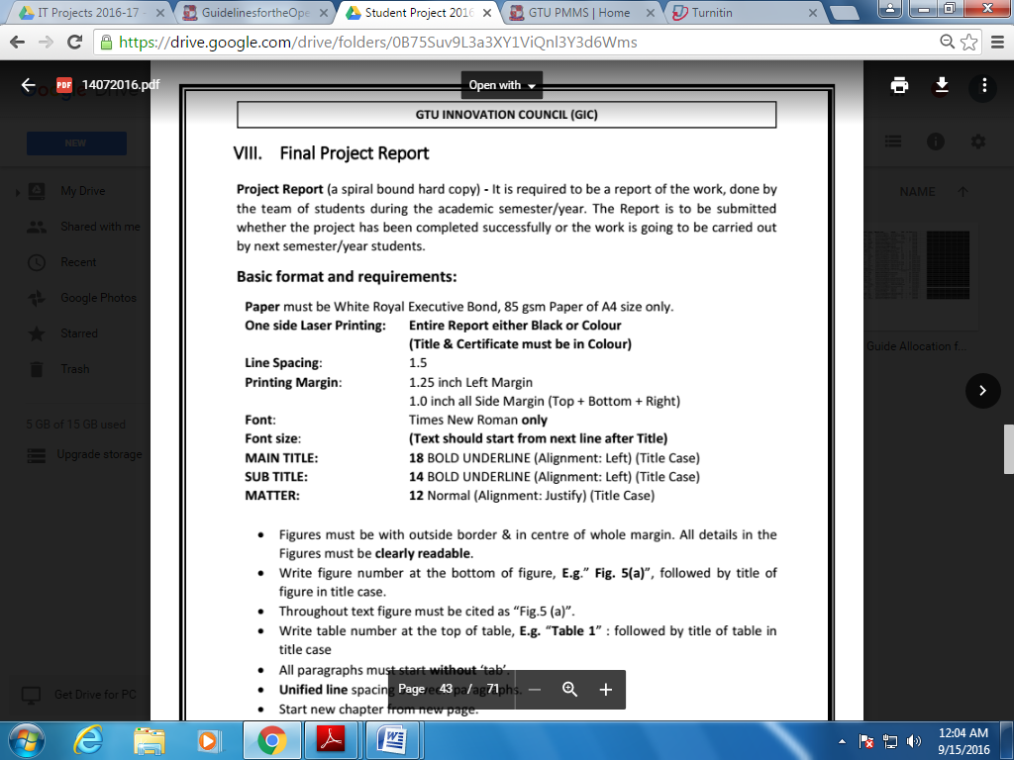

* Figures must be with outside border & in center of whole margin. All details in the Figures must be clearly readable.
* Write figure number at the bottom of figure, E.g.” Fig. 5(a)”, followed by title of figure in title case.
* Throughout text figure must be cited as “Fig.5 (a)”.
* Write table number at the top of table, E.g. “Table 1” : followed by title of table in title case.
* All paragraphs must start without ‘tab’.
* Unified line spacing between paragraphs.
* Start new chapter from new page.
* No blank area at the end of each page except last page of chapter.
* All equations in the middle of line with equation no. at the end of line within small brackets, E.g.(2).
* No dots between equation and equation no. space before and after equation sign.
* **Chapter heading must be identical for each new chapter (in right top side corner header).**

**For header Footer:**

* **Left Top- Enrollment Number**
* **Right Top- Chapter Name**
* **Left Bottom- LJIET-IT/ICT [Either of it]**
* **Right Bottom- Page Number**

**Guidelines for Final Year Project Report: The Project report should have following components:**

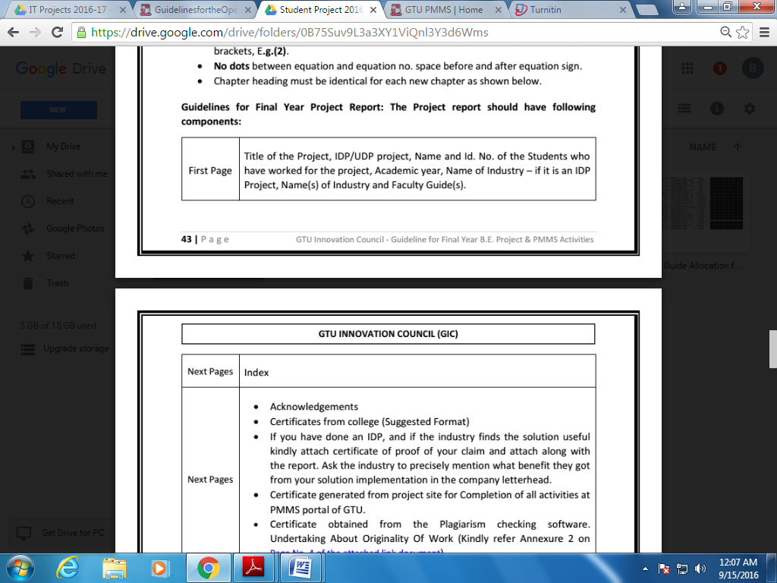

|  |  |  |
| --- | --- | --- |
| **Sr. No** | **Index** | **Page** |
| I | **Acknowledgement** | **Page num for these should be in roman** |
| II | **Abstract** |
| III | **Table of Content** |
| IV | **List of Figures** |
| V | **List of Tables** |
| VI | **List of Abbreviation** |
| **Chapter 1** | **Introduction** | 1 |
| 1.1 | Introduction to System. | 2 |
| 1.2 | Limitation of Existing System.(IF ANY) | Onwards |
| 1.3 | Objective of the new system. |  |
| 1.4 | Problem definition. |  |
| **Chapter 2** | **Requirement Analysis** |  |
| 2.1 | Feasibility study |  |
| 2.2 | Requirement Of System (Functional and Non Functional) |  |
| 2.3 | Tools and Technology used |  |
| 2.4 | Project Estimation |  |
| **Chapter 3** | **System Design** |  |
| 3.1 | Use case Diagram |  |
| 3.2 | Activity Diagram |  |
| 3.3 | Data Flow Diagram |  |
| 3.4 | Sequence Diagram |  |
| 3.5 | * Class Diagram |  |
| 3.6 | * E-R Diagram |  |
| 3.7 | * State Diagram |  |
| **Chapter 4** | Data Dictionary |  |
| **Chapter 5** | Snapshot |  |
| **Chapter 6** | Future Enhancement |  |
| **Chapter 7** | Conclusion |  |
| **Chapter 8** | References |  |
| **Chapter 9** | Appendix |  |
| 9.1 | Periodic Progress Reports (PPR) |  |
| 9.2 | Business Model Canvas(BMC) |  |
| 9.3 | Patent Drafting Exercise(PDE) |  |
| 9.4 | Certificate Obtained from Plagiarism Checking. |  |

**Note: According to your project you have to draw the diagrams which are applicable for your project.**

**Students need to submit their project report of the work done for whole project in spiral bound as follows:**

1. Student Copy.

2. Dept. Copy/Guide Copy in spiral bound.

* **Sequence for Project Report SpiralBinding.**

1. Title Page
2. Certificate from College
3. Certificate form Company. (If Applicable)
4. Project Completion Certificate.
5. Declaration of Originality.
6. Index.